**­CSC 1101 – Problem Solving and Programming Laboratory – Winter 2019**

**Lab 07 – Trevor Trusty**

**25 points – Due February 5, end-of-class**

**a)** Save this document with your name and the lab assignment number somewhere in the file name.

**b)** Type/paste your answers into the document.

c) Submit this document and your .cpp file(s) to the Canvas item where you downloaded this document. Do not submit a zip file but individually attach your files.

Prompt the user for three students’ first names, last names and exam grades. Calculate the average exam grade and output your results into two columns, one for names and the other for grades. Make a copy of the C++ template for your applicationand make the following edits:

1) Rename the copy you made to **yourName_InClass_Lab07.cpp** and save

it into your *CSC1101* folder.

2) Complete the header comment.

3) Modify the application header and close to contain the application name.

4) Declare constants for column widths.

5) Declare variables for names (**string**) and grades (**double**).

6) Using **cin >>**, prompt the user for student names and grades.

7) Calculate the average grade.

8) Output the names and grades to two decimal places into two columns. Your output format should look like this:

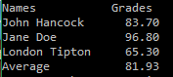

*[your program code here]\**

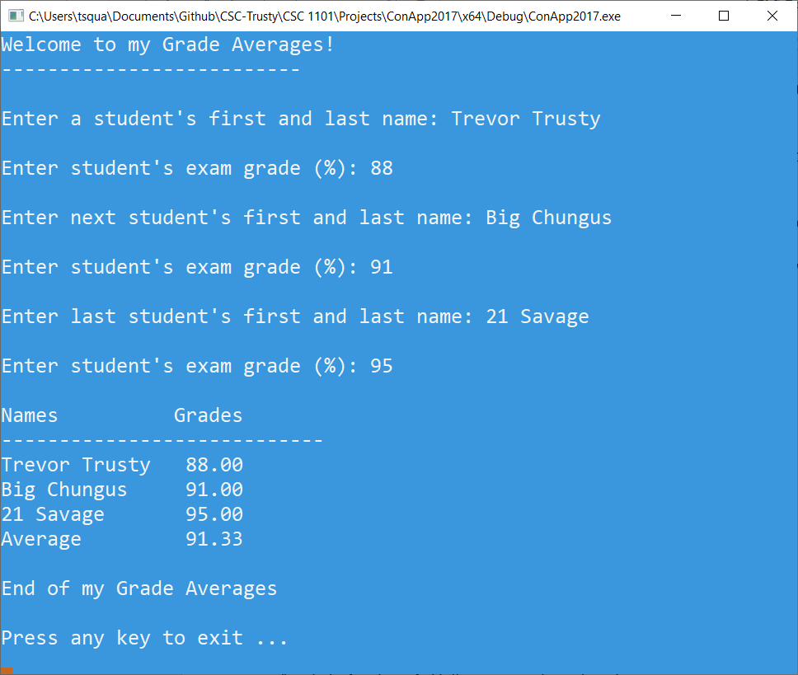

**//==========================================================**

**//**

**// Title: Grade Averages**

**// Course: CSC 1101**

**// Lab Number: Lab 7**

**// Author: Trevor Trusty**

**// Date: 2/5/2019**

**// Description:**

**// Takes the grades of three students and shows the average**

**// grades.**

**//**

**//==========================================================**

**#include <conio.h> // For function getch()**

**#include <cstdlib> // For several general-purpose functions**

**#include <fstream> // For file handling**

**#include <iomanip> // For formatted output**

**#include <iostream> // For cin, cout, and system**

**#include <string> // For string data type**

**using namespace std; // So "std::cout" may be abbreviated to "cout"**

**int main()**

**{**

**//Declare variables and constants**

**string firstName1, lastName1, firstName2, lastName2, firstName3, lastName3;**

**string name1, name2, name3;**

**char p = ' ';**

**double examGrade1, examGrade2, examGrade3, avg;**

**const int COL1 = 15;**

**const int COL2 = 6;**

**// Show application header**

**cout << "Welcome to my Grade Averages!" << endl;**

**cout << "--------------------------" << endl << endl;**

**//Prompt user for Student 1's grade**

**cout << "Enter a student's first and last name: ";**

**cin >> firstName1 >> lastName1;**

**cout << endl;**

**cout << "Enter student's exam grade (%): ";**

**cin >> examGrade1;**

**cout << endl;**

**//Prompt user for Student 2's grade**

**cout << "Enter next student's first and last name: ";**

**cin >> firstName2 >> lastName2;**

**cout << endl;**

**cout << "Enter student's exam grade (%): ";**

**cin >> examGrade2;**

**cout << endl;**

**//Prompt user for Student 3's grade**

**cout << "Enter last student's first and last name: ";**

**cin >> firstName3 >> lastName3;**

**cout << endl;**

**cout << "Enter student's exam grade (%): ";**

**cin >> examGrade3;**

**cout << endl;**

**name1 = firstName1 + p + lastName1;**

**name2 = firstName2 + p + lastName2;**

**name3 = firstName3 + p + lastName3;**

**avg = examGrade1 + examGrade2 + examGrade3;**

**avg /= 3;**

**//Show average grade table**

**cout << fixed << setprecision(2);**

**cout << setw(COL1) << left << "Names";**

**cout << setw(COL2) << left << "Grades" << endl;**

**cout << "----------------------------" << endl;**

**cout << setw(COL1) << left << name1;**

**cout << setw(COL2) << right << examGrade1 << endl;**

**cout << setw(COL1) << left << name2;**

**cout << setw(COL2) << right << examGrade2 << endl;**

**cout << setw(COL1) << left << name3;**

**cout << setw(COL2) << right << examGrade3 << endl;**

**cout << setw(COL1) << left << "Average";**

**cout << setw(COL2) << right << avg << endl;**

**// Show application close**

**cout << "\nEnd of my Grade Averages" << endl << endl;**

**// Pause before application window closes**

**cout << "Press any key to exit ..." << endl;**

**_getch();**

**}**

*[your program output here]\*\**

* **Copying-and-pasting Visual C++ code to a Word document**

1) From within the Visual C++ program, press **CTRL-A** and press **CTRL-C**.

2) From within the Word document, press **CTRL-V**.

** **Copying-and-pasting Visual C++ console application output to a Word document**

1) From the Visual C++ console, press **ALT-PrintScreen**.

2) From within the Word document, press **CTRL-V**.